Cloud computing is the **delivery of computing services over the internet ("the cloud")** instead of relying on a personal computer or on-premises server.

These services include:

* **Servers** (virtual machines, storage servers, etc.)
* **Storage** (databases, file storage, backups)
* **Networking** (load balancers, content delivery networks)
* **Software and Applications** (SaaS tools like Gmail, Office 365, Zoom)
* **Analytics, AI, and more**

**Key Idea:**

Instead of buying and maintaining your own hardware/software, you **rent resources** from cloud providers like **Amazon Web Services (AWS), Microsoft Azure, or Google Cloud Platform (GCP)**. You pay for what you use, just like electricity or water.

**Characteristics of Cloud Computing:**

1. **On-demand self-service** – Users can provision resources without human interaction with the provider.
2. **Broad network access** – Services are available over the internet on laptops, mobiles, etc.
3. **Resource pooling** – Providers share resources across multiple customers.
4. **Rapid elasticity** – Scale resources up or down as needed.
5. **Measured service** – Pay-as-you-go billing based on usage.

**Types of Cloud:**

* **Public Cloud** – Services offered to everyone over the internet (AWS, Azure, GCP).
* **Private Cloud** – Exclusive to one organization, often on-premises.
* **Hybrid Cloud** – Mix of public and private clouds.

**Service Models:**

1. **IaaS (Infrastructure as a Service)** – Renting servers, storage, networking. (e.g., AWS EC2, Google Compute Engine)
2. **PaaS (Platform as a Service)** – Ready-to-use platforms for app development (e.g., Google App Engine, AWS Elastic Beanstalk).
3. **SaaS (Software as a Service)** – Ready-to-use applications (e.g., Gmail, Dropbox, Zoom).

## ****IaaS vs PaaS vs SaaS****

| **Aspect** | **IaaS (Infrastructure as a Service)** | **PaaS (Platform as a Service)** | **SaaS (Software as a Service)** |
| --- | --- | --- | --- |
| **Definition** | Provides **virtualized computing resources** like servers, storage, networking. | Provides a **platform** with tools to build, run, and deploy apps without managing infrastructure. | Provides **ready-to-use software applications** over the internet. |
| **What you manage?** | You manage: OS, applications, middleware, runtime. | You manage: Applications & data only. | You manage: Nothing (only use the app). |
| **Provider manages** | Hardware, networking, virtualization. | Hardware, networking, virtualization, OS, middleware. | Everything (infrastructure, platform, and software). |
| **Users** | IT admins, DevOps, system engineers. | Developers (focus on coding, not infra). | End users (business & individuals). |
| **Examples** | AWS EC2, Microsoft Azure VM, Google Compute Engine, DigitalOcean. | Google App Engine, AWS Elastic Beanstalk, Heroku, Microsoft Azure App Service. | Gmail, Google Docs, Dropbox, Salesforce, Zoom. |
| **Use Case** | Build custom infrastructure for flexible apps, host VMs. | Build & deploy apps quickly without worrying about servers. | Use applications directly via browser. |

## ****Public vs Private vs Hybrid Cloud****

| **Aspect** | **Public Cloud** | **Private Cloud** | **Hybrid Cloud** |
| --- | --- | --- | --- |
| **Definition** | Services delivered over the internet and shared among multiple users. | Cloud infrastructure dedicated to a single organization (on-premises or hosted). | Combination of public + private cloud with data/applications shared between them. |
| **Ownership** | Owned & operated by a third-party provider (AWS, Azure, GCP). | Owned/managed by a single organization or a private hosting provider. | Joint responsibility between organization and public provider. |
| **Accessibility** | Anyone can access via the internet (pay-per-use). | Restricted to one organization (secure, internal use). | Some resources on private, some on public cloud. |
| **Cost** | Low upfront cost (pay-as-you-go). | High setup and maintenance cost. | Moderate – use private for sensitive data and public for scalable workloads. |
| **Security** | Standard security (depends on provider). | Highly secure (dedicated environment). | Balanced – sensitive data in private, less critical in public. |
| **Scalability** | Highly scalable. | Limited scalability (depends on hardware). | Scalable (public handles extra demand). |
| **Examples** | AWS, Microsoft Azure, Google Cloud. | VMware Cloud, OpenStack Private Cloud. | Azure Hybrid Cloud, AWS Outposts, Google Anthos. |

## 🌩️ ****What is AWS?****

**Amazon Web Services (AWS)** is the world’s most widely used **cloud computing platform**, launched by Amazon in **2006**.  
It provides **on-demand cloud services** like servers, storage, databases, networking, machine learning, analytics, and much more — all available **over the internet** on a **pay-as-you-go** basis.

## 🚀 ****Key Features of AWS****

1. **On-demand resources** – Quickly launch servers or services without buying hardware.
2. **Pay-as-you-go pricing** – Pay only for what you use, no upfront investment.
3. **Global infrastructure** – Data centers (called Regions and Availability Zones) across the world.
4. **Scalability & elasticity** – Easily scale up during peak loads and scale down when demand drops.
5. **Security & compliance** – Highly secure environment with compliance certifications.

## 🏗️ ****AWS Global Infrastructure****

* **Regions** → Physical locations worldwide (e.g., N. Virginia, Mumbai, Singapore).
* **Availability Zones (AZs)** → Each region has multiple AZs (isolated data centers).
* **Edge Locations** → Content delivery points for fast performance (used in CloudFront CDN).

## 🔑 ****AWS Service Categories****

AWS has **200+ services**, but the main categories are:

1. **Compute** → EC2 (virtual servers), Lambda (serverless), ECS/EKS (containers).
2. **Storage** → S3 (object storage), EBS (block storage), Glacier (archival storage).
3. **Databases** → RDS (relational DB), DynamoDB (NoSQL), Aurora (cloud-native DB).
4. **Networking** → VPC, Route 53 (DNS), CloudFront (CDN).
5. **AI/ML** → SageMaker, Rekognition, Translate.
6. **Security** → IAM (Identity & Access Management), KMS (Key Management).
7. **Developer Tools** → CodeDeploy, CodePipeline.

## 🎯 ****Why use AWS?****

* **Cost-effective** – No need to buy expensive servers.
* **Highly scalable** – From startups to enterprises.
* **Reliable & secure** – Used by Netflix, NASA, Airbnb, and millions of others.
* **Flexible** – Supports different operating systems, databases, programming languages.

# 🌩️ ****AWS Global Infrastructure****

AWS infrastructure is designed for **high availability, scalability, and fault tolerance**. It consists of **Regions, Availability Zones (AZs), Local Zones, and Edge Locations**.

## 1️⃣ ****Regions****

* A **Region** is a physical location in the world where AWS has data centers.
* Each region consists of **multiple Availability Zones**.
* Example:
  + us-east-1 (N. Virginia, USA)
  + ap-south-1 (Mumbai, India)
  + eu-central-1 (Frankfurt, Germany)
* As of 2025 → **~33 launched regions** with more upcoming.

## 2️⃣ ****Availability Zones (AZs)****

* Each **Region** has **2 to 6 AZs** (separate, isolated data centers).
* AZs are connected with **low-latency, high-speed fiber links**.
* Purpose: If one AZ fails (e.g., power outage, natural disaster), the others keep services running.
* Example:
  + us-east-1a, us-east-1b, us-east-1c are AZs in N. Virginia region.

## 3️⃣ ****Local Zones****

* AWS **Local Zones** are **extensions of regions** placed near major cities.
* They bring AWS services **closer to end-users** for low-latency apps (gaming, media, real-time apps).
* Example: AWS Local Zone in **Los Angeles** for media production.

## 4️⃣ ****Wavelength Zones****

* AWS Wavelength integrates AWS services into **telecom 5G networks**.
* Helps deliver **ultra-low latency** apps (IoT, AR/VR, autonomous vehicles).

## 5️⃣ ****Edge Locations (CDN with CloudFront)****

* AWS has **450+ Edge Locations** worldwide.
* They are used by **Amazon CloudFront** (CDN) to cache data and deliver content faster.
* Example: Watching Netflix in India → Content is served from the nearest AWS Edge Location instead of the US.

## 🏗️ ****Hierarchy****

Global

└── Regions (e.g., ap-south-1)

└── Availability Zones (e.g., ap-south-1a, ap-south-1b)

└── Local Zones

└── Wavelength Zones

└── Edge Locations

## 🎯 ****Benefits of AWS Global Infrastructure****

* **Fault Tolerance** → Multiple AZs ensure high availability.
* **Low Latency** → Regions & Edge locations ensure fast performance.
* **Scalability** → Can expand globally in minutes.
* **Compliance** → Data residency requirements (store data in specific regions).

👉 In short:

* **Regions** = Geographic locations.
* **AZs** = Isolated data centers inside regions.
* **Local/Wavelength Zones** = Bring AWS closer to users.
* **Edge Locations** = Deliver cached content worldwide.

# 🔒 ****AWS Shared Responsibility Model****

The **Shared Responsibility Model** defines **who is responsible for what** in terms of security and compliance in the cloud.

* **AWS** handles security **of** the cloud.
* **Customer (you)** handles security **in** the cloud.

## 🏗️ ****Breakdown****

| **Responsibility** | **AWS (Security of the Cloud)** | **Customer (Security in the Cloud)** |
| --- | --- | --- |
| **Infrastructure** | Physical security of data centers, servers, networking, storage, power, HVAC. | Not applicable. |
| **Compute & Storage** | Protects virtualization layer, hypervisors, hardware, storage disks. | You configure EC2 instances, S3 buckets, databases. |
| **Networking** | Global network security, DDoS protection at infra level. | Configure VPC, firewalls, routing tables, NACLs, security groups. |
| **Data** | Ensures durability & availability of storage systems (like S3). | You encrypt data, manage access keys, handle backups. |
| **Identity & Access** | Provides IAM service. | You set IAM policies, manage user roles, MFA, permissions. |
| **Applications** | Provides PaaS/SaaS security baseline. | You patch/update OS, applications, runtime, and secure code. |
| **Compliance** | Maintains global compliance certifications (ISO, SOC, PCI-DSS, etc.). | You ensure compliance with your own industry regulations (GDPR, HIPAA). |

## 🔑 ****Simple Rule****

* **AWS manages everything they control physically and globally.**
* **You manage everything you deploy, configure, and store.**

## 🏠 ****Analogy (Apartment Building 🏢)****

* AWS = The building owner → takes care of the structure, electricity, elevators, security guards.
* You (customer) = Tenant → lock your door, install cameras inside your flat, manage who enters.

## 🎯 ****Why It Matters****

* Misunderstanding leads to **data breaches** (e.g., public S3 buckets without encryption).
* Shared responsibility ensures **clarity of roles** → AWS won’t patch your app, and you don’t need to worry about physical data center guards.

👉 In short:

* **AWS** secures the infrastructure (hardware, network, global operations).
* **You** secure your resources (apps, OS, data, access).

# 🏗️ ****AWS Well-Architected Framework****

The **AWS Well-Architected Framework (WAF)** is a set of **best practices and guidelines** for designing secure, efficient, reliable, and cost-effective cloud systems.

It helps architects **evaluate workloads** and make sure applications are:

* **Secure**
* **High-performing**
* **Resilient**
* **Cost-optimized**
* **Sustainable**

## 📚 ****The 6 Pillars of the Well-Architected Framework****

### 1️⃣ ****Operational Excellence****

* Focus: Operations, monitoring, continuous improvement.
* Best practices:
  + Automate deployments.
  + Use Infrastructure as Code (IaC).
  + Track metrics and logs.

### 2️⃣ ****Security****

* Focus: Protecting data, systems, and assets.
* Best practices:
  + Identity & Access Management (IAM).
  + Data encryption (S3, RDS, KMS).
  + Monitoring & threat detection (CloudTrail, GuardDuty).

### 3️⃣ ****Reliability****

* Focus: System availability & recovery.
* Best practices:
  + Multi-AZ deployments.
  + Backup & Disaster Recovery (DR).
  + Automatic scaling & self-healing systems.

### 4️⃣ ****Performance Efficiency****

* Focus: Using resources efficiently.
* Best practices:
  + Use right instance types.
  + Auto Scaling for dynamic workloads.
  + Caching (CloudFront, ElastiCache).

### 5️⃣ ****Cost Optimization****

* Focus: Avoiding unnecessary costs.
* Best practices:
  + Pay-as-you-go.
  + Use Spot & Reserved Instances.
  + Monitor billing with AWS Cost Explorer.

### 6️⃣ ****Sustainability**** (added in 2021)

* Focus: Minimizing environmental impact.
* Best practices:
  + Use energy-efficient instance types.
  + Reduce unused resources.
  + Choose regions powered by renewable energy.

## 🎯 ****Benefits of Well-Architected Framework****

* Improves **security** & **compliance**.
* Enhances **performance** & **scalability**.
* Reduces **costs**.
* Supports **business continuity**.
* Promotes **sustainable cloud usage**.

**AWS EC2**

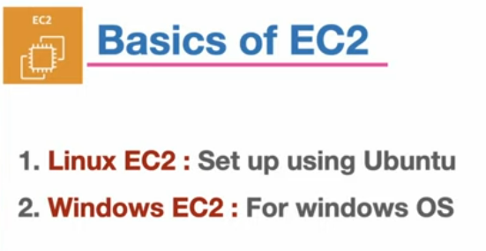

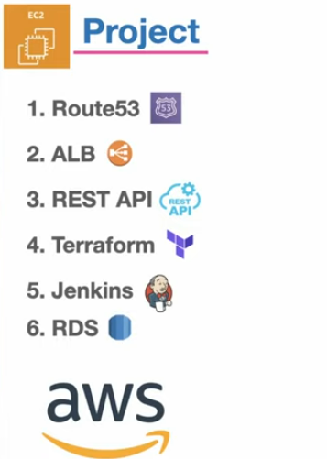

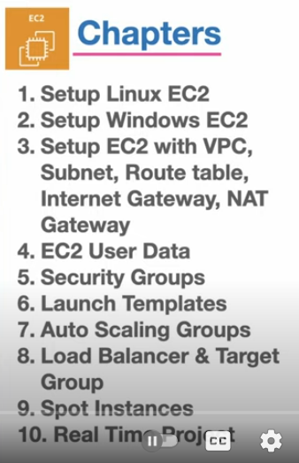

**Ec2🡪virtual server 🡪 region(Europe,asia,etc…)**

**EC2 🡪memory,cpu,storage,networking setup 🡪 t3.nano, t3.micro,t3.small,Etc…..**

**How to launch an instance?**

**Go to aws->ec2->instance ->launch an instance( name ,os,amazon machine image ,architecture,instance type(cpu),key pair(.pem pdf),network setting,configuration storage) ->launch an instance(submit)->click on instance->on connect**

**Keypair:-**

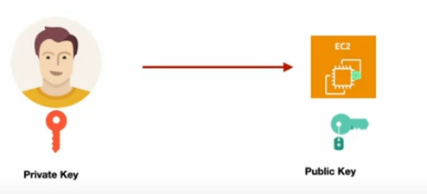

**In network setting**

**Allow RDP TRAFFIC FROM**

**If ip address is 0.0.0.0/0 means anyone can access**

**U can allow ssh,http,https**

**And always auto-assign public ip is enable**

**On submit launch an instance**

**Instance state- running(4 state- running ,waiting,terminating,stopped)**

**By SSH client :**

**While connect ->go to SSH CLIENT**

**Go to command prompt go to that file we got of key-pair(.pem) ->ls –lart ->paste commands that is give in connection ssh client**

**2.Set up your first windows EC2 Instance**

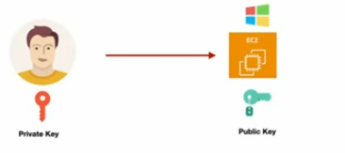

Launch instances-> name->os->instance type->create key pair ->network settings -> configure storage->click on launch instances

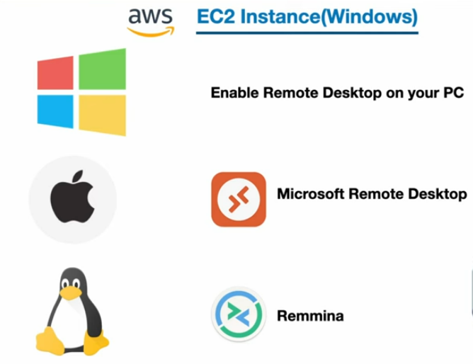

[Enable Remote Desktop on your PC | Microsoft Learn](https://learn.microsoft.com/en-us/windows-server/remote/remote-desktop-services/remotepc/remote-desktop-allow-access) - enable remote desktop on your pc

Come to our created instance click on connect ( Session manager, RDP client, EC2 serial console)->

We gona use RDP client

* Connect your RDP client
* Download remote desktop file
* Get password(we will use key we have created during instance->upload it here) -> copy password we get (we will use this for run our pc in local server)->Save(store username,password,Public dns)

Now, open remote desktop client PC name- Public dns then it ask username and password paste it over here

**3 Setup EC2 alongwith VPC, Subnet ,CIDR Internet Gateway Route table**

In this ,we gone setup EC2 instance in public and private subnet

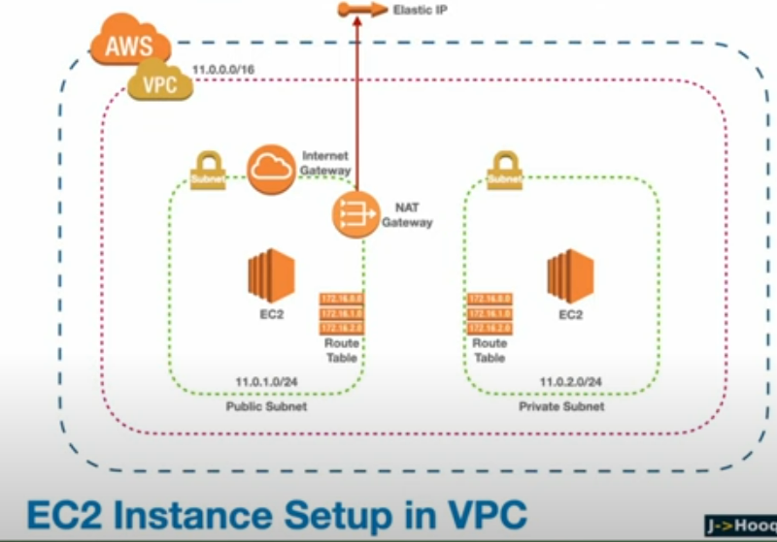

Home page aws console-> search VPC ->create VPC (after completiting steps)-> click on create VPC

CREATE VPC –

Resources to create- VPC only

* Name tag
* IPv4 CIDR block
* IPv4 CIDR – enter subnet like 11.0.0.0/16
* IPv6 CIDR block

[CIDR block basically बताता है कि तुम्हारे network में कितने **IP addresses** available होंगे।

* Format: IP Address/Subnet Mask
* Example: 192.168.1.0/24

]

Now,vpc is created -> now create public and private subnet

On VPC dashboard click on subnets -> create subnet->click on submit create subnets

Create subnet-

* Select vpc id
* Subnet1

Subnet name

Availability zone

IPv4 VPC CIDR block

IPv4 subnet CIDR block

Now, inside aws vpc is created with 2 subnets now add internet gateway(📌 **Practical Example:**  
मान लो तुम्हारा घर एक **VPC (Virtual Private Cloud)** है।

* घर के अंदर कई कमरे हैं = EC2 instances
* घर के अंदर लोग आपस में बात कर सकते हैं (local network)
* लेकिन अगर तुम्हें बाहर की दुनिया (Internet) से बात करनी है, तो तुम्हें **Main Gate** खोलना पड़ेगा।

👉 वही **Main Gate = Internet Gateway** है।

) in public subnet

On vpc dashboard -> internet gateway->create(name tag)-> create internet gateway

Now come to internet gateway click on action select attach to vpc(select vpc)

Now we gone to create route tables inside the subnets

On VPC dashboard –route table-> create(name, select vpc )

Make two route table (public and private)

Connect each route table with their subnets

Go to public route table -> subnet association -> edit subnet associations(select public subnet)

Now go to each routes table -> routes(add routes acc to their subnets)

NAT Gateway(Network Address Translation Gateway) (**Private subnet के instances को Internet access देना**, लेकिन **Internet से directly access ना होने देना**।)

On VPC dashboard NAT Gateway -> create NAT Gateway(name,subnet(created in public),elastic ip -> created nat gateway

Now we have to create a route for our private subnet route table so that they nat gateway(associate nat gateway with private subnet)

Got to private route tables click on edit routes 0.0.0.0/0 select nat gateway

Now create EC2 instances in each subnet

Go to aws-> launch instances for each subnet

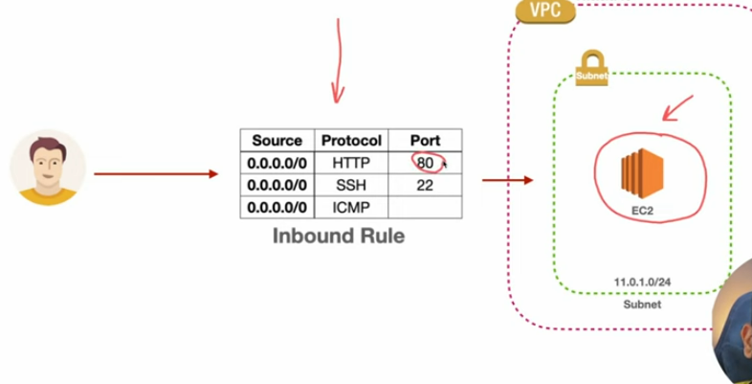

**4 AWS EC2 User data script**

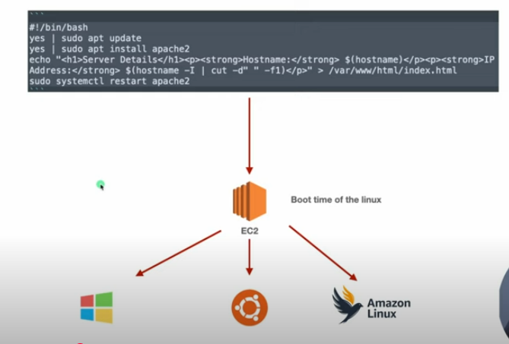

This is window ec2 user data script

Launch an instance(name,os,instance type,keypair(login),etwork settings,securitygroup,configuration storage,user data)->launch->take public dns,username,password from rdp client connect with server using remote desktop

On window machine->browser search localhost -> output

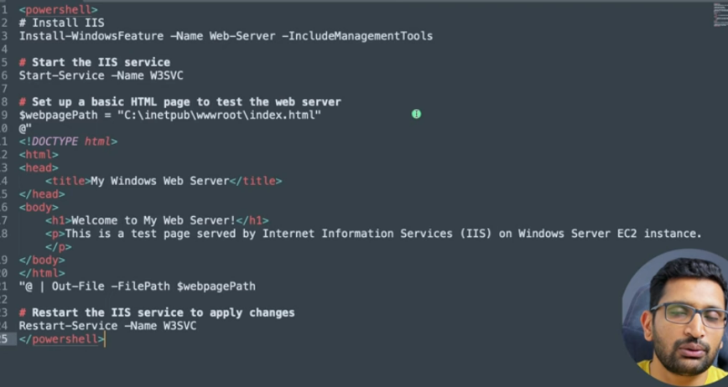

Ubuntu user data

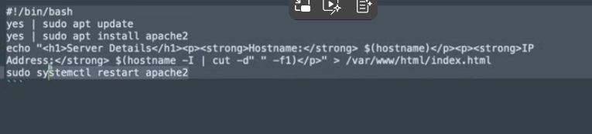

Linux user data

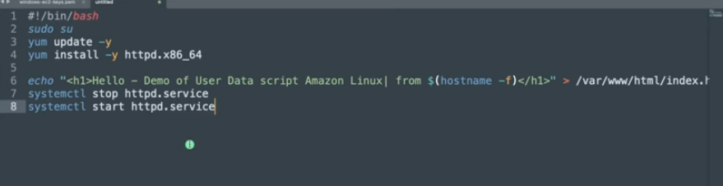

**5 EC2 Security Group**

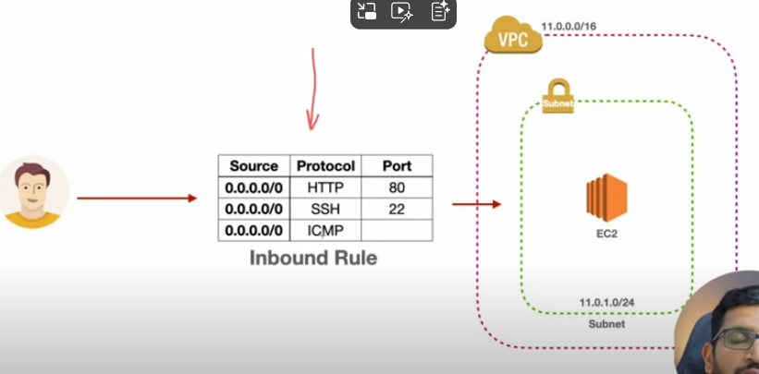

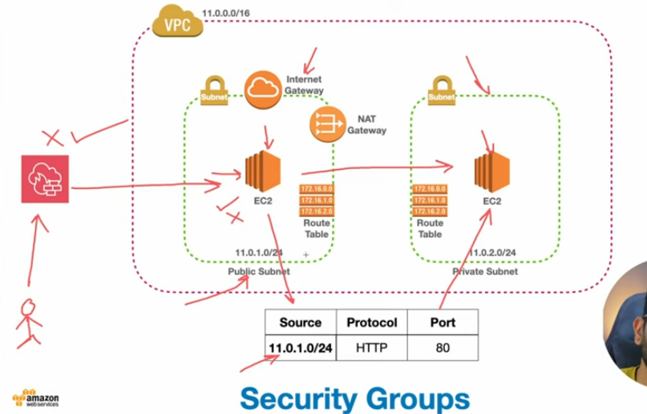

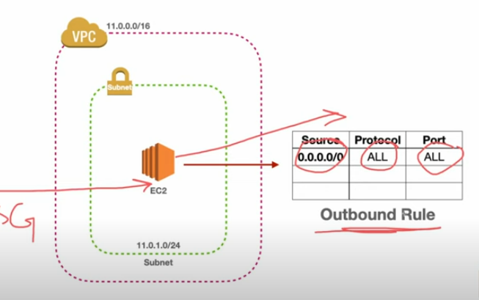

First we launch instance(in networking section- security group( create security group, select existing security group)-type,protocol,port – launch instance

Click on created instance -> connect -> ssh client

In instance click on security group-> edit inbound rules

Curl ipinfo.io

**6 EC2 launch template**

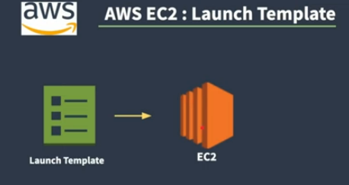

How to launch template for ec2

Go to aws dashboard ->EC2 -> launch instance

On EC2 Dashboard -> launch templates ->create launch template-> ec2 dashboard->click on drop down of launch instance-> select launch instance from template->choose launch template->connect->ssh client->run commands on command prompt

Create launch template:-

* Name
* Description
* Template tags
* Source template(pre existing template)
* Select os image
* Create new key pair
* Network setting(security group)
* Storage
* User data

In launch template we can differnentiate is docker or not /ubntu or not many more

**7 AWS Auto scaling groups**

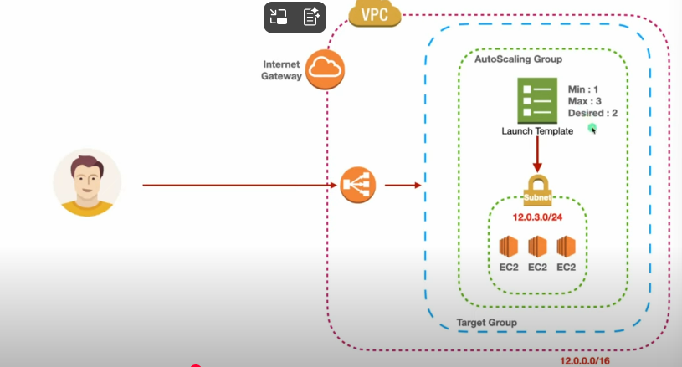

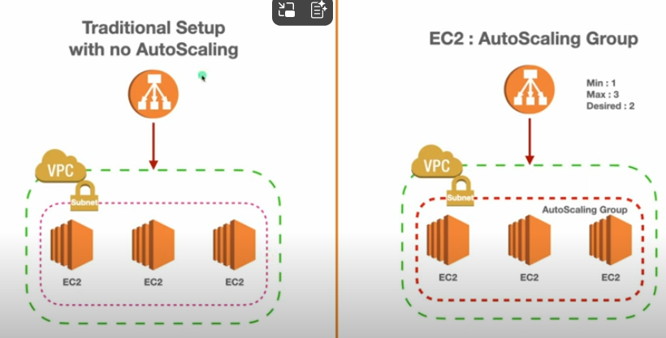

**Traditional Setup (Left Side)**

* You manually launch a fixed number of EC2 instances.
* Example: 3 EC2 instances are running.
* If demand increases (more traffic), you must **manually add** more EC2 instances.
* If demand decreases (low traffic), instances still run, so you **pay for unused resources**.
* If one instance fails, it is **not automatically replaced**.
* Less flexible, more manual management.

**EC2 Auto Scaling Group (Right Side)**

* You define scaling rules with parameters like:
  + **Min**: Minimum number of EC2 instances (e.g., 1).
  + **Max**: Maximum number of EC2 instances (e.g., 3).
  + **Desired**: Target number of instances (e.g., 2).
* Auto Scaling Group automatically:
  + **Adds new EC2s** if traffic load increases.
  + **Terminates EC2s** if traffic load decreases.
  + **Replaces unhealthy EC2s** automatically.
* More **cost-efficient** (pay only for what you use).
* Ensures **high availability** and fault tolerance.

According to picture,

Go to aws dashboard -> vpc (create vpc) -> internet gateway(create internet gateway)->vps dashboard->subnet(create subnet) -> route tables

Click on ec2-> load balancing-> target groups(create target group)->create load balancer-> auto scalling(auto scaling group)

For pointing the load balancer to the target groups add target to the listeners and routing while creating load balancers

Auto Scaling Group:-

Choose launch template(type of ec2) or configuration

Choose instance launch options

Configure advanced options

Configure group size and scaling poilicies

Add notifications

Add tags

Review

**8 AWS EC2 application load balancer and target group**

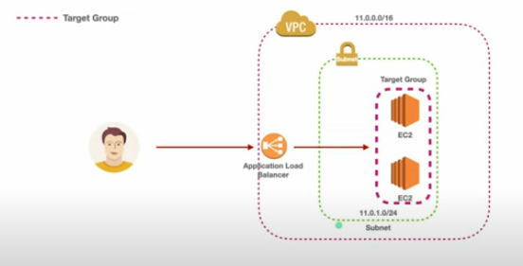

Go to aws dashboard -> ec2-> launch instance-> go to EC2 -> load balancer -> target groups(create target group for instances) -> create load balancer

**9 EC2 EBS Volume**

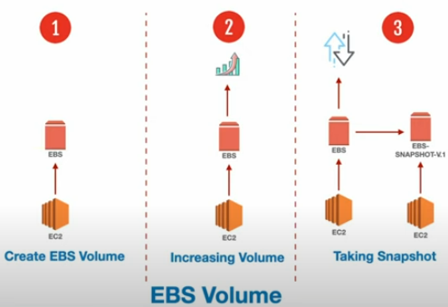

**How to create EBS volume**

**Go to aws dashboard -> launch an instance-> connect->ssh client(run commands of ssh client)->ec2 dashboard ->elastic block store ->volumes(create volume)->click on action drop down ->attach volume->run some commands on command prompt check volume**

Now we gone create EBS snapshot

Create 2 files in ec2 instance(create folder-> sudo touch 1.txtlike this)->ec2 ->launch instances-> connect instance(run ssh commands on command prompt)->ec2-> elastic block store(volumes)-> action(create snapshot)-> snapshot action(create volume from snapshot)-> go to that which we have created just-> volume action(Attach volume)

**10 AWS EC2 Spot Instances**

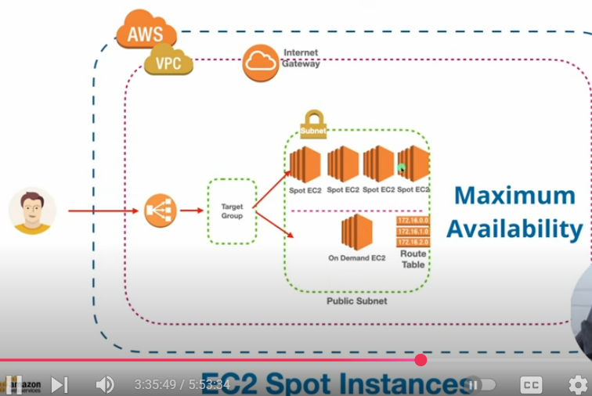

Go to aws dashboard ->vpc(create vpc)->subnet(public)->internet gateway connect with public subnet-> route table(connect with subnet)->EC2 instances-> Spot Requests(request spot instances)->first launch templates before spot request(create)-> launch instances-> target groups(create)

**11. EC2 LIVE PROJECT**

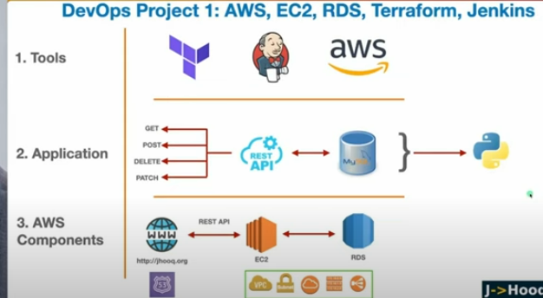

**CHAPTER-1**

Github repostiroy- restapi, aws tools,jenkins

**CHAPTER-2**

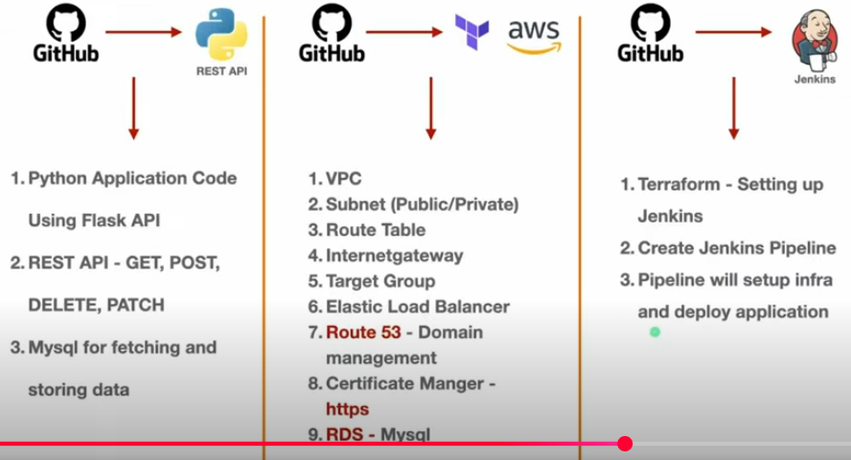

**CHAPTER-3**

**Install terraform in your local machine-terraform init, terraform plan,terraform apply**

**Jenkins setup**

**Chapter-4**

**Jenkins setup-**

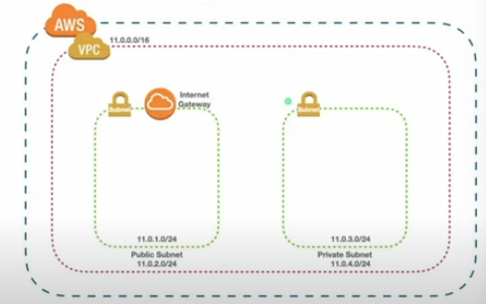

**Chapter-5**

**Create internet gateway**

**terraform apply –auto-approve(we have folder in which internet gateway is created by run this command we get created internet gateway in our aws)**

**chapter -6 route table**

public and private route table

**chapter-7 ec2 instances +Jenkins**

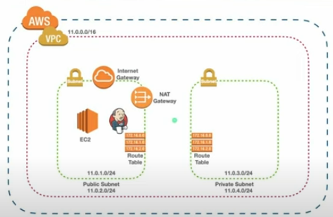

* Create security groups
* Jenkins- get public key by running commands in command prompt
  + Ssh-keygen
  + Ls –lart
  + Cart filepath 🡺we get content copy that this is public key

Search on browser Jenkins installation on Ubuntu

Open linux copy the content-> paste it in Jenkins-installer

Copy the ip address from Jenkins instance

Chapter-8 jenkins setup

Pasted the ip address in browser

Command prompt:-

Cd .ssh

Ls –lart

Go to instance –connect ->open ssh client run these commands in command prompt

Now copy the path we get after pasting the ip address in browser and now run command in command prompt 🡺 sudo cat pastepath here in output get key copy it and paste it in browser content

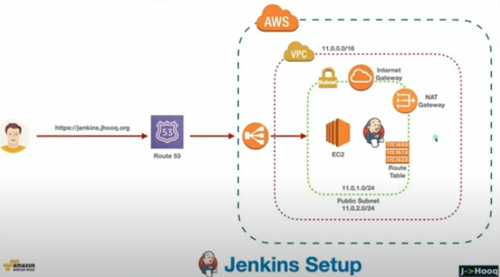

**Chapter-9 Load balancer**

Set up load balancer-> target group

**Chapter-10 ALB,Hosted Zone**

On aws dashboard -> route 53 –> hosted zone -> create hosted zone

Certificate manager

**Chapter-11 Deploy RestAPI**

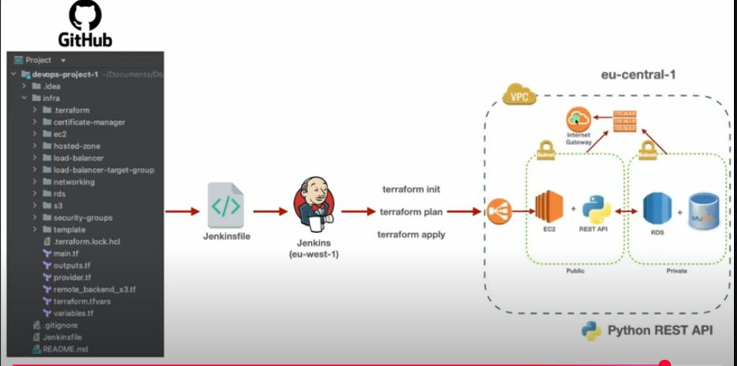

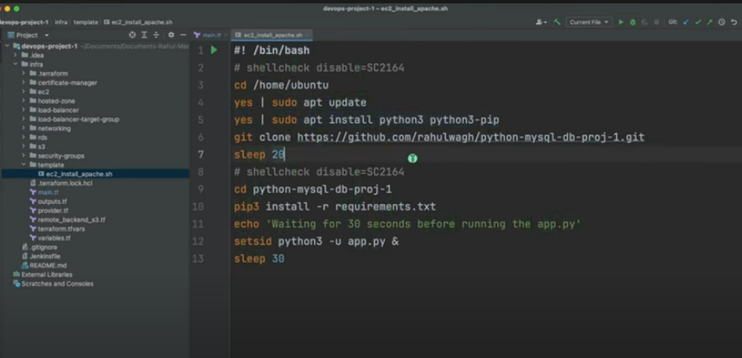

**COMPLETED EC2 INSTANCE AND VPC**

**IAM**

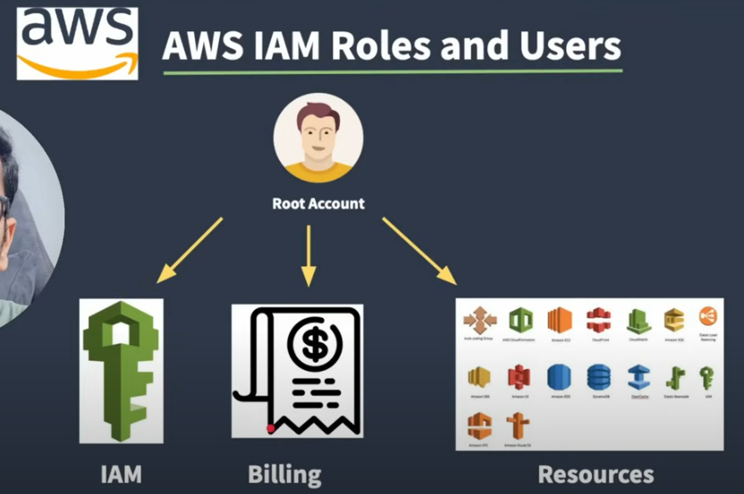

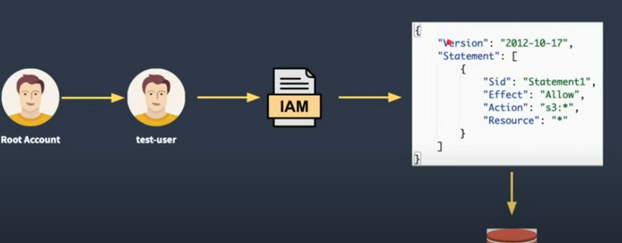

first we create user go to IAM dashboard ->users(create user) ->permissions(add permissions-> attach policy directly)

Create user :-

Specific user details

Set permissions

Review and create

We get ,ARN which is used in instances and also in security credentials we get aws console as a user we have created like test user

If u login as a user or iam user u haven’t access to create s3 buckets where as root user have access to create buckets

Go to IAM dashboard as a root user ->Policies ->create policy

While creating policy we gone to set up policies like permissions

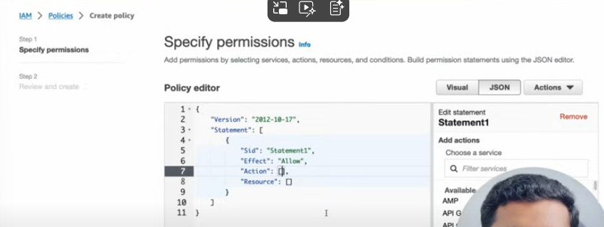

In this we allow acces s3 bucket to all user .as we have seen as a iam user we have no acces to create bucket list but after add permission to user attach with policy we get access of s3

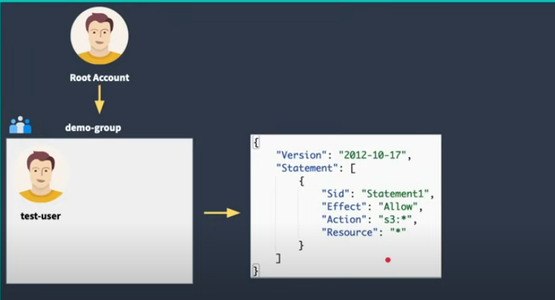

Now we gone to create user group

Go to IAM dashboard -> User groups(Create)-> after creating group -> add users init-> add permissions also(attach policies,create inline policy) but we go with attach policies.

**AWS Organization**

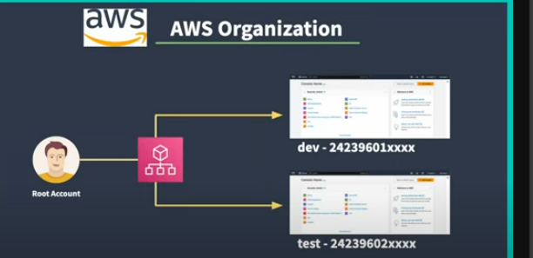

In this we can create multiple account under an organization

Aws dashboard -> aws organization-> select root go to action create new account organizational unit

**AWS Role : Assume role**

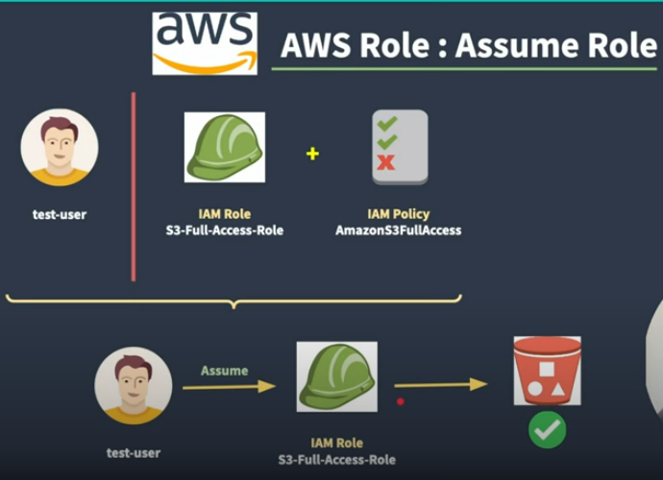

Go to test-user aws console -> s3 it does not have access to create bucket so first we create role attach policy with it then assign this role as a assume role to user

Go to IAM dashboard -> roles(aws account,permission policy(s3),role name)->create role-> now assign this role to particular user-> go to users ->test-user(created user)->click on add permission (create inline policy)-> go to roles click on policy (copy link to switch role)-> paste it on another browser(Switch role)

Create inline policy:-

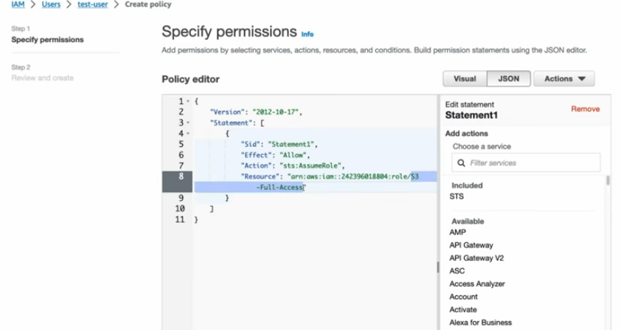

**AWS EC2 Auto Scalling Groups**

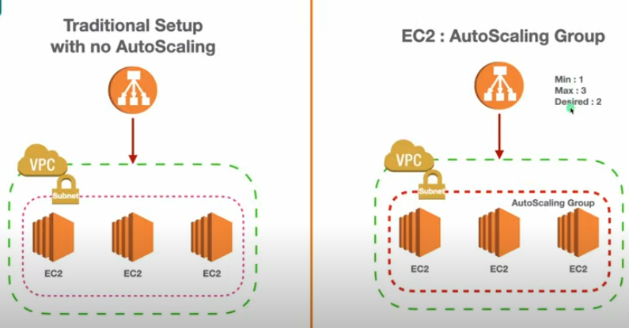

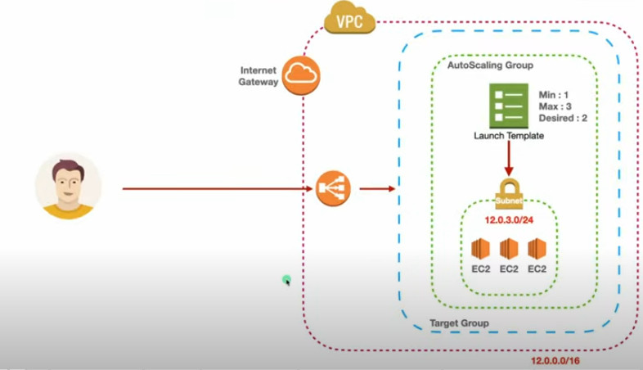

First create vpc -> internet gateway after creating gateway action->attach to vpc-> subnets(create)-> route tables(create)-> edit routes(add route)->Target group(ec2->loadbalancer->targetgroup->create)->create load balancer(application bcz we r using instances)->create launch template before autoscaling group-> Auto scaling group

**S3**

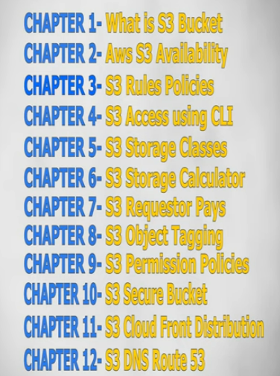

S3 is simple storage device

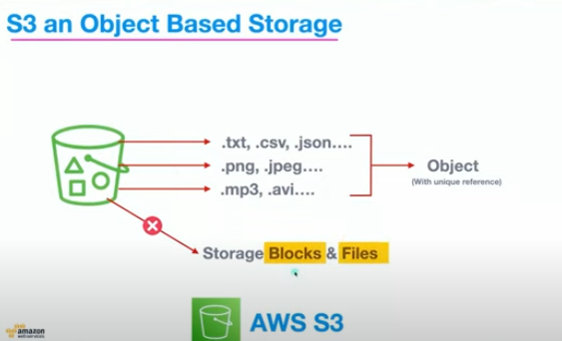

Create s3 bucket

Aws dashboard->s3 dashboard(create bucket)->upload object to bucket

Chapter-2 AWS S3 AVAILABILITY

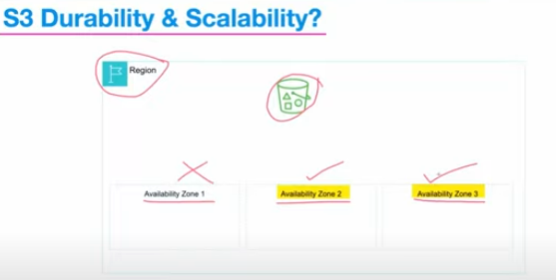

Chapter-3

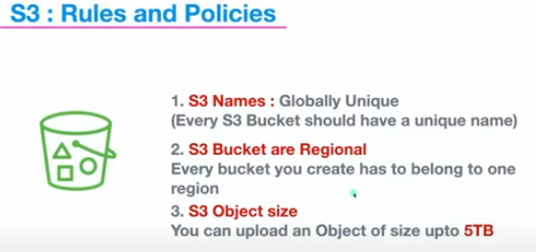

Chapter-4

accessing s3 using cli

* + - AWS CLI DOWNLOAD
    - Aws –version
    - Aws configure(security credentials in aws account)
    - Test Connectivity :- aws sts get-caller-identity
    - List buckets :- aws s3 ls
    - Content inside the bucket :- aws s3 ls s3://nameof bucket
    - Move the bucket :- aws s3 mv s3://nameof origin bucket s3://nameof dest bucket
    - View all the child content inside the bucket :- aws s3 ls s3://name of bucket –recursive

Chapter-5

S3: Storage classes

S3 standard :

1. Default
2. Highly durable
3. Ideal for frequent acces
4. Low latency

S3 standard ia(infrequent access):

1. Cost effective
2. Suitable for infrequent access
3. Supports high availability

S3 Intelligent –tiering:

1. Move data between two access tiers
2. Optimize costs based on usage patterns

S3 one zone-IA:

1. LOW COST
2. Suitable for infrequent access
3. Single availability zone
4. Reduced durability

S3 Glacier Instant retrieval:

1. Low cost
2. Suitale for archival data
3. Retrieval in milliseconds

S3 glacier instant retrieval:

1. Low cost for archival
2. Flexible retrieval options- mins to houres

S3 glacier deep archieve:

1. Lowest cost storage
2. Retrieval within 12 hours

Chapter-6

S3 storage calculator

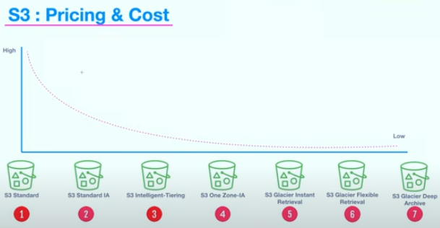

Go to aws pricing calculator -> create estimator -> add services and storage

Chapter-7

S3: Requestor Pays

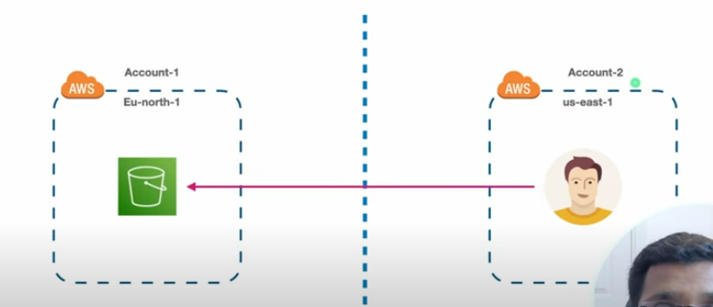

Go to s3 buckets-> click on created bucket -> properties->requester pays(edit->enable)

Chapter-8

S3: Object Tagging

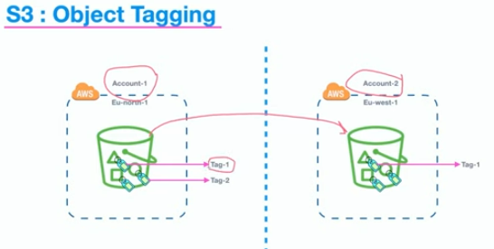

Go to s3bucket->click on bucket created->on its object->tags(upto 10)

Chapter-9

S3:Bucket Policy

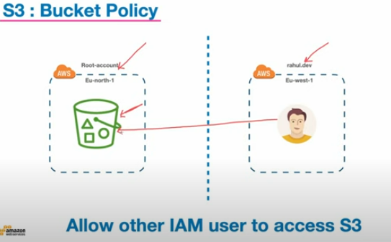

Go to s3 buckets ->click on created bucket->Go to IAM (create user)-> policy in iam(create policy->service->list)->user(iam)->click on user->permissions policies->add permissions-> now user’s aws console have access of bucket

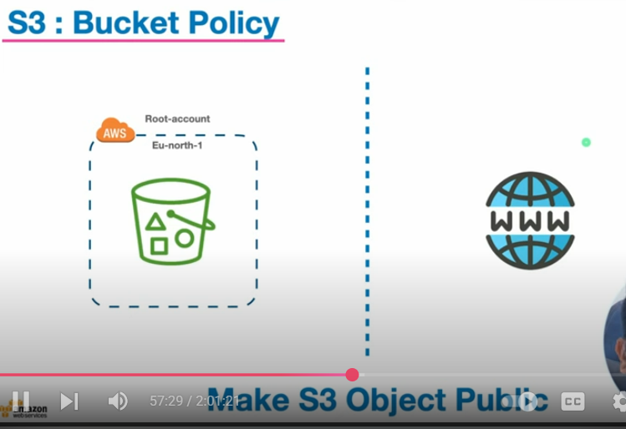

First we create the bucket->bucket policy(policy generator)->upload object in bucket

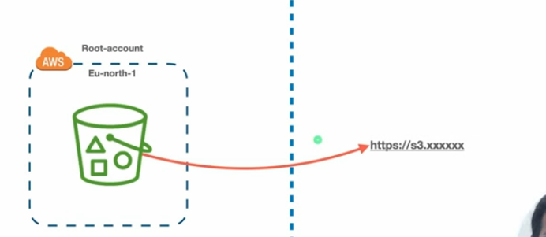

Go to bucket ->upload object->select object->presigned urls

Chapter-10

S3 Secure Bucket

* AWS SSE-S3 Encryption
* AWS S3 SSE-KMS
* In transit encryption
* Bucket versioning
* Bucket Replication and batch job

Go to s3 dashboard->click on created bucket->properties->default encryption(edit) for aws sse-s3 encryption

Go to s3 dashboard->click on created bucket->properties(default encryption)->ss with aws sse-kms

Go to s3 ->click on created bucket->get url(https/http)-🡪in transit ENCRYPTION

Go to s3->click on created bucket->permission->bucket policy(edit)

Go to s3->click on created bucket->properties->bucket versioning(edit)

Go to s3->create two buckets(like src,dest name)->default encryption enable firstone->go to src bucket->management->replication(create replicationrule->choose destination bucket)->we go to batch oprn page(status:active)->now all obj of src into dest.

Chapter-11

S3:Cloud Front Distribution

Go to aws dashboard –> cloud front(create)->copy policy->go to created bucket that we have selected as a origin ->permissions->edit policy paste it here

Chapter-12

SetUp Static Website S3

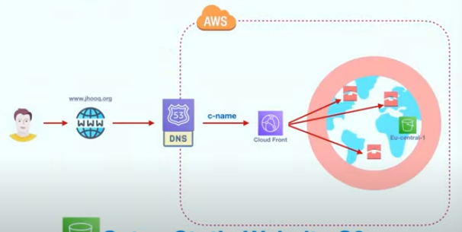

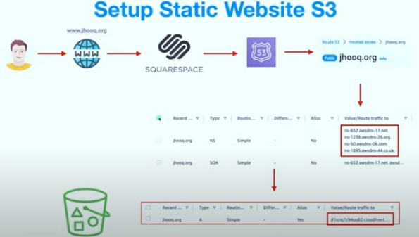

Aws dashboard->route 53->Hosted zone->register all .org.. in square space

Create s3 bucket->upload files->cloud front(create distribution->copy policy)->route53(create)->click on created s3 bucket->permissions(bucket policy)

**COMPLETED S3**

**ROUTE 53**

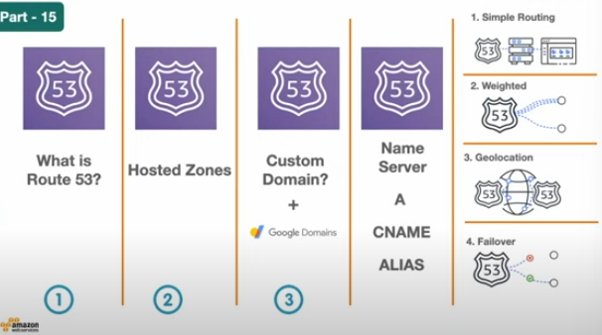

Step 1 what is route 53

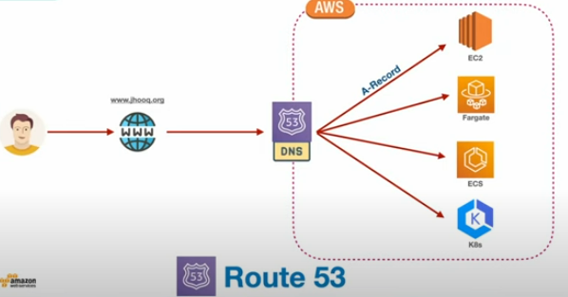

**1. User Request**

* A user enters a domain name in their browser (e.g., **www.jhooq.org**).
* The browser needs to know the **IP address** of the server hosting this website.

**2. DNS Resolution (Route 53 Role)**

* The request goes to **Route 53 DNS**.
* Route 53 stores DNS records (like **A-Record**, which maps a domain name to an IP address).

**3. Routing to AWS Resources**

* Route 53 resolves the domain and directs traffic to different AWS services:
  + **EC2 (Elastic Compute Cloud)** → Virtual servers running applications.
  + **Fargate** → Serverless compute engine for containers.
  + **ECS (Elastic Container Service)** → Orchestrating Docker containers.
  + **K8s (Kubernetes on AWS EKS)** → Kubernetes clusters running workloads.

**4. Key Concept**

* **A-Record**: It maps the **domain name** (e.g., www.jhooq.org) to the **IP address** of the target resource (EC2, ECS, etc.).
* Route 53 acts as the **bridge between human-readable names (domain)** and **actual cloud resources**.

**5. In Short**

* User types domain → Route 53 DNS lookup → Routes to AWS resource → Website/App is served.

✅ **So Route 53 = AWS’s DNS + Traffic Routing Service.**

### 🔑 Common DNS Record Types in Route 53

1. **A Record (Address Record)**
   * Maps a domain name → IPv4 address (e.g., 192.0.2.1).
   * Example:
   * www.example.com → 192.0.2.1
2. **AAAA Record**
   * Maps a domain name → IPv6 address.
   * Example:
   * www.example.com → 2001:db8::1
3. **CNAME (Canonical Name Record)**
   * Maps one domain name → another domain name (alias).
   * Example:
   * www.example.com → app.example.com
4. **NS Record (Name Server Record)**
   * Specifies which DNS servers are authoritative for a domain.
   * Example:
   * example.com → ns-123.awsdns-45.org
5. **SOA Record (Start of Authority Record)**
   * Provides information about the domain, such as:
     + Primary name server
     + Contact email of domain admin
     + Domain serial number
     + Refresh/expiry times for caching
   * Used by DNS to manage zones.
6. **MX Record (Mail Exchange Record)**
   * Directs email to mail servers.
   * Example:
   * example.com → mail.example.com (priority 10)
7. **TXT Record**
   * Stores text information. Commonly used for:
     + Domain verification
     + SPF, DKIM, DMARC (email authentication)
   * Example:
   * example.com → "v=spf1 include:_spf.google.com ~all"
8. **SRV Record**
   * Defines location of specific services (protocol, port, target).
   * Example:
   * _sip._tcp.example.com → sipserver.example.com port 5060
9. **Alias Record (Route 53 specific)**
   * AWS-only feature. Similar to CNAME but can be applied at the **root domain (apex)**.
   * Can point to AWS resources like:
     + Load Balancers
     + CloudFront distributions
     + S3 buckets
     + Another Route 53 record

**Step2 : Hosted Zone(creation)**

Route53->create hosted zone->google domain->DNS ->custom name server(add name server of aws hosted zone here)

Demo:Setup A record

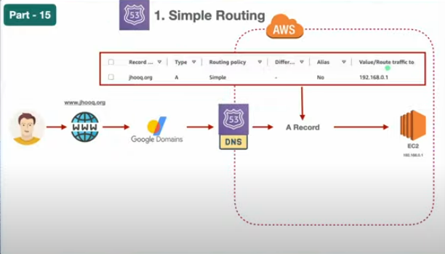

On EC2 launch instance->route53->hosted zone(click on created on hosted zone u want to use)->create record(simple policy or many more policy)

We use loadbalancer which help in end of providing static ip address

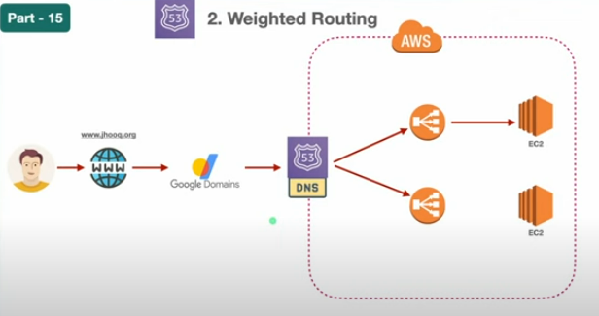

In this first set up networking

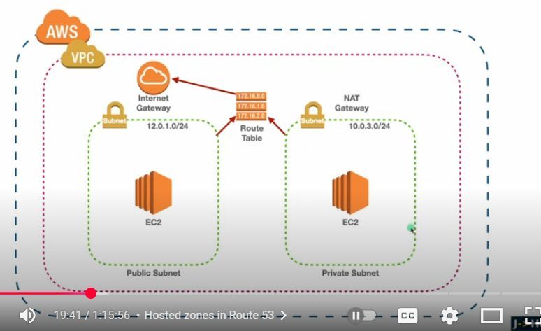

Go to aws->vpc(create)->subnet(create for public and private) under vpc->internet gateway(attach to vpc)-> route tables(create for public and private)->click on public route table->action(edit subnet association)->edit routes of public route table->instances(launch instance->network edit add vpc we have created)->target group(create)->load balancer(create)

Now we have to fixing routing of route 53 and loadbalancer

Route53->select created hosted zone->create record-(select load balancer instead of ip address)🡺 this is one load balancer

Now come to multiple load balancer

Launch instance->load balancer(create)->route53->hosted zone created one->create record(add multiple load balancer)

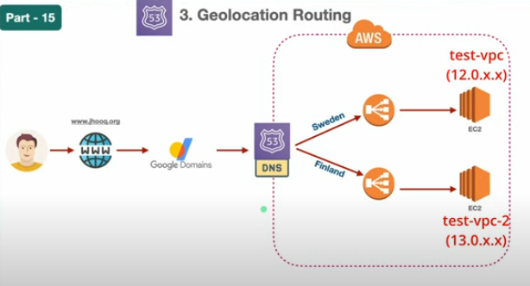

Route 53->choose hosted zone ->create record->geolocation->record type->load balancer->location->define geolocation record

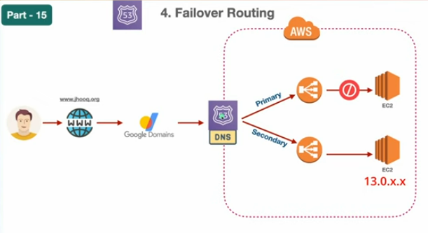

**Route53**->choose hosted zone->create record->failover->record type->define failover record

**SES**

AWS **SES (Simple Email Service)** ka use mainly email bhejne aur receive karne ke liye hota hai. Ye ek **scalable, cost-effective aur reliable cloud-based email service** hai jo developers aur businesses dono ke kaam aati hai.

AMAZON SES -> set up

SES me **identity** ka matlab hai **konsa email address ya domain** aap use kar rahe ho emails send/receive karne ke liye.  
Ye verify karna zaroori hota hai taaki AWS sure ho ki aapko us domain/email se bhejne ka right hai (anti-spam & security ke liye).

AWS SES->create identity->send test email

## 🔑 DKIM in AWS SES

**DKIM (DomainKeys Identified Mail)** ek **email authentication mechanism** hai jo ensure karta hai ki:

1. Email **genuine hai** (sender ne bheja hai, spoof nahi hai).
2. Email ka **content transit me change nahi hua**.

AWS SES automatically **cryptographic signature** attach karta hai outgoing emails me agar DKIM enabled hai.

## ⚙️ How DKIM Works in SES

1. Aap **Domain ko identity** ke taur pe verify karte ho.
2. AWS aapko **3 CNAME records** deta hai.
   * Ye CNAME records basically **public keys** hoti hain jo DNS me daalni padti hain.
   * Example:
   * Name: abcde12345._domainkey.myapp.com
   * Type: CNAME
   * Value: abcde12345.dkim.amazonses.com
3. Jab AWS SES email bhejta hai → us email me **private key se signature add hoti hai**.
4. Recipient mail server DNS se aapke domain ka **public key (CNAME record)** check karta hai.
5. Agar match hota hai → email **authenticated** aur **trusted** maana jata hai (spam folder me jane ki chances bahut kam ho jaate hain).

## ✅ Benefits of DKIM in SES

* Emails spam/junk folder ke bajaye inbox me deliver hote hain.
* Improves **domain reputation**.
* Helps with compliance (SPF + DKIM + DMARC = industry standard).
* Prevents **email spoofing**.

## 📌 Steps to Enable DKIM in SES

1. AWS Console → **SES → Domains → Verify a New Domain**.
2. Domain enter karo → select **Generate DKIM Settings**.
3. AWS aapko **3 CNAME records** dega.
4. Unko apne DNS provider me add karo (Route53, GoDaddy, Cloudflare, etc.).
5. SES console me DKIM status → “**Verified**” ho jayega after propagation (may take few minutes to hours).

⚡ Example Flow:

* Domain: myapp.com
* AWS ne diya:
  + abcde12345._domainkey.myapp.com → abcde12345.dkim.amazonses.com
  + fghij67890._domainkey.myapp.com → fghij67890.dkim.amazonses.com
  + klmno11223._domainkey.myapp.com → klmno11223.dkim.amazonses.com

Add these in DNS → DKIM enabled ✅

**Custom mail from domain**-> mailed by edit krskte hm apni custom name dal skte h it will give record add in your dns records if not in route 53

**Domain –based message authentication,reporting and conformance(DMARC)**- > it specifies how email servers should handle messages that fail the authentication checks

**Bounce rate**->span emails

**Complaint rate**->report emails

**Suppression list** -> add emails that will be bounce(means spam or not existed register user -> jisse reputation khrab hogi)

**Email Receiving**-> set up receipt rules add IP address filters specifying whar you wanr amazon SES to do with emails it receives on your behalf.-> create identity-> create rule set(only one rule active at a time-> add receipient condition(domainsubdomain ,email)->action)

**Smtp settings**

If u want to take it in production u need to create sandbox(**get set up**)

**CLOUDWATCH**

Amazon **CloudWatch** is a monitoring and observability service in AWS.  
It helps you track **metrics**, collect **logs**, set **alarms**, and get insights into the performance and health of your AWS resources and applications.

Think of it as **CCTV + Health Monitoring** for your AWS environment.

Advantage of cloudwatch:-

* Monitoring
* Real life metrics(metrics like cpu utilization,api calls)
* Alarms
* Log insights
* Custom metrics
* Cost optimization
* Scaling

Aws ->cloudwatch-> logs->log groups(create log group)

Log group like u r creating lot of projects inside codebuild log group is created for each project inside code build which help in tracking individual project activity.

AWS -> CLOUDWATCH ->Metrics

Metrics(information related to ec2 or s3 or any other thing)

AWS ->first launch instance(cloudwatch-demo)->run instance (ssh –i aws_login.pem Ubuntu publicip)-> run command (top)->cloudwatch->metrics->ec2 instance-> across all instances(select metrics)->go to instance created->monitoring(u see selected metric display)

Alarm->use like if cpu utilization reach 60 % give me an alarm

Aws->cloudwatch->alarm-> in alarm(create alarm)

**RDS(relational database service)**

It is a managed database service that simplifies database setup,operation and scaling

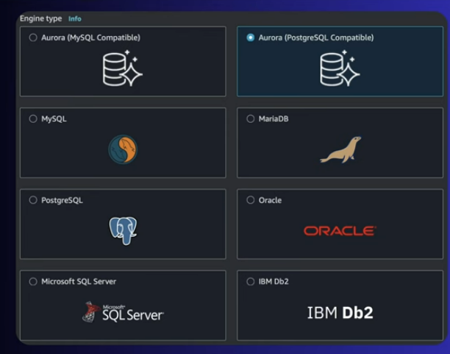

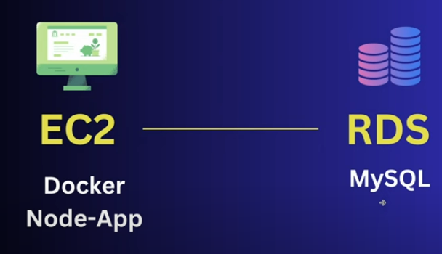

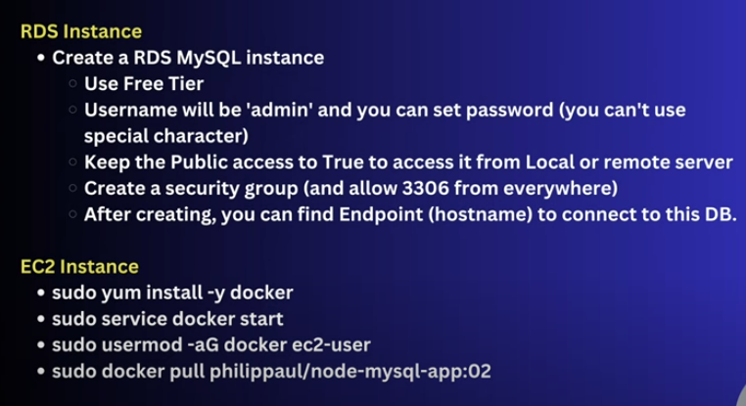

Aws->RDS ->databases(create database)->aws->create instance->ec2 instance connect-> run commands that are written above-> on created database->security group(edit inbound rules ->mysql)-> run below command with sudo->sudo docker ps->sudo docker logs –f competent_sanderson(folder name)->ec2 instance running(copy public ip->paste on browser)-> run command below 2nd one

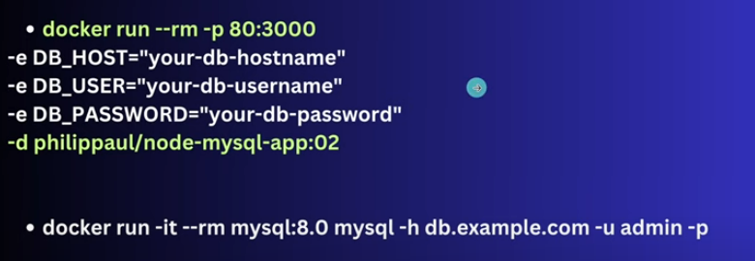

In database create database endpoint is hostname

The command docker run –it –rm mysql:8.0 vali isme db.example.com ki jgh hostname now u can execute sql quereies

**Snapshots(in amazon rds)**

An **Amazon RDS Snapshot** is a **backup** of your RDS database at a specific point in time.  
It captures the **entire DB instance**, including data, schema, and configurations.

Think of it like a **photo of your database** that you can restore later.

## 🔹 Types of Snapshots in RDS

1. **Automated Snapshots (Backups)**
   * Managed by AWS automatically if **automated backups** are enabled.
   * Created daily (or as per backup window).
   * Stored in **Amazon S3** (but you don’t see it directly).
   * Retention period: **1–35 days**.
2. **Manual Snapshots**
   * You create them manually anytime.
   * Not deleted automatically (you must delete when no longer needed).
   * Useful for **before major changes** (e.g., schema migration, upgrades).

## 🔹 Key Features

* **Restoration**: You can restore a DB instance from a snapshot at any time.
* **Point-in-time recovery**: Automated backups + transaction logs allow recovery to a specific second within the backup retention window.
* **Cross-Region & Cross-Account Sharing**:
  + Copy snapshots to another region for disaster recovery.
  + Share manual snapshots with other AWS accounts.

## 🔹 Use Cases

1. **Disaster Recovery**  
   If your DB fails or gets corrupted → restore from snapshot.
2. **Testing & Development**  
   Create a snapshot of production DB → restore into a new DB for testing.
3. **Migration / Upgrades**  
   Take snapshot before upgrading engine version or making major changes.
4. **Long-Term Backup**  
   Keep manual snapshots for compliance/auditing.

## 🔹 Example Flow

1. You have an RDS MySQL DB running.
2. Before making changes, you create a **Manual Snapshot**.
3. If changes fail → restore DB from snapshot to previous state.
4. Or → copy snapshot to another region for DR setup.

✅ **In short**:

* **Automated Snapshots = AWS-managed daily backups** (expire after X days).
* **Manual Snapshots = User-created backups** (stay until you delete them).

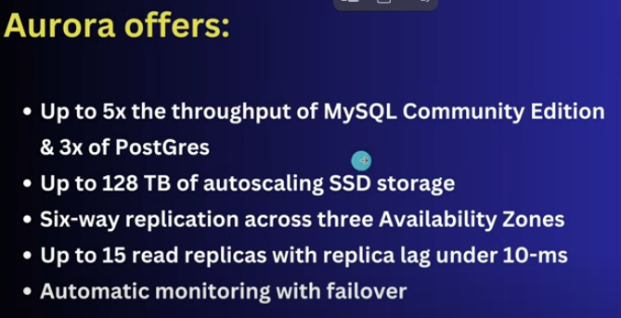

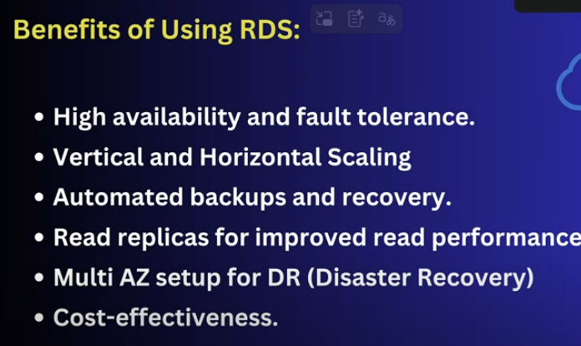

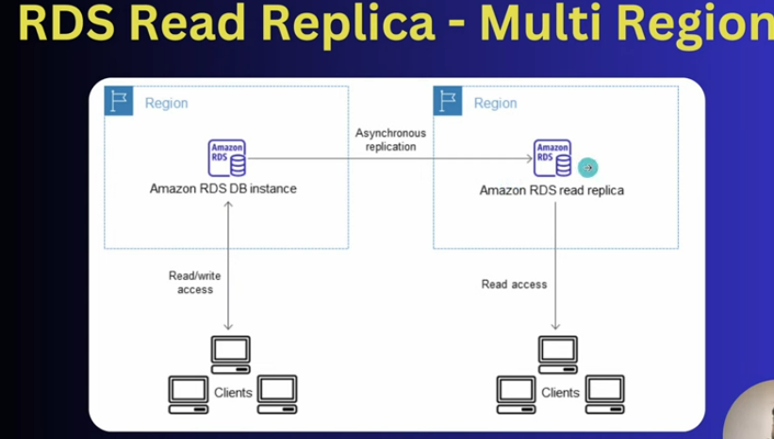

**Dynamo DB**

It stores data as items in tables, with each item represented as a JSON-Like document consisting of Key-value pairs.

Aws-> Dynamo DB -> create table-> edit capacity(read,write)

DynamoDB is

* Serverless
* Automatic Scaling
* Zero Downtime
* On-Demand Pricing
* Idle Cost Savings

Practical Time :- Docker Based Node App with Dynamodb

For any programming language based application for run we can use aws sdk

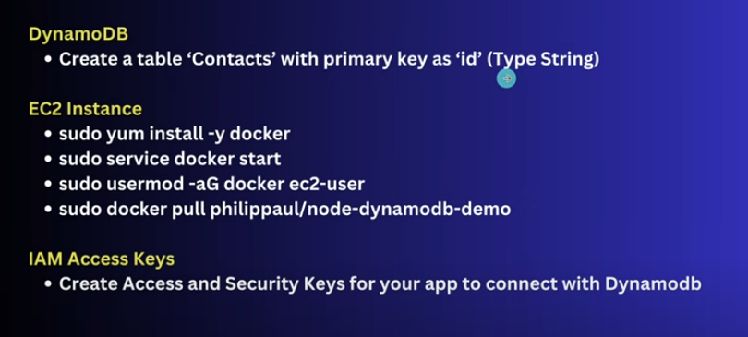

Aws-> ec2(launch instance)->connect(ec2 instance)->run commands(give above)->IAM Dashboard->users(security credentials-> create access key->cli(get access key,secret access key)->Roles(create role)->instance(action->modify iam role->select role u have created)

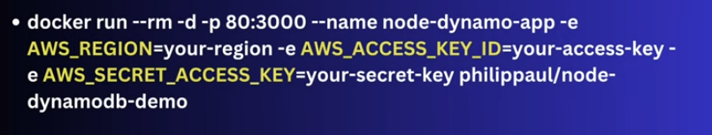

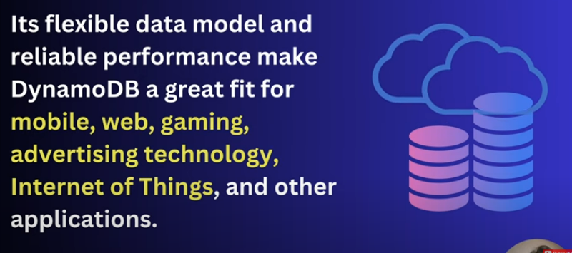

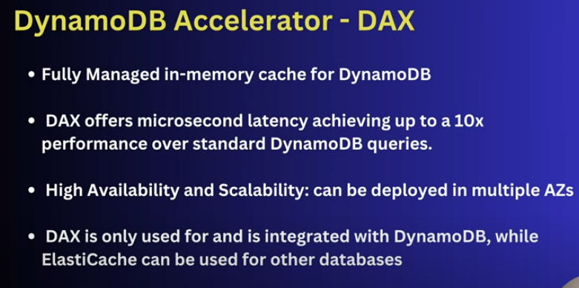

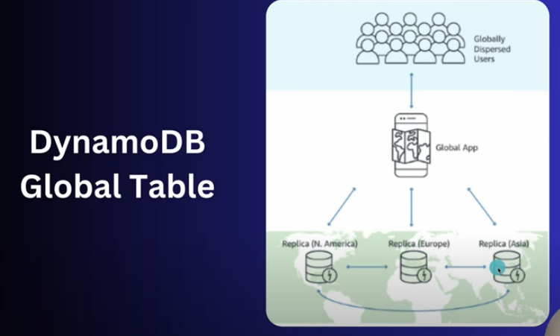

**CLOUDFRONT**

It is a content delivery network that speeds up the delivery of web content to users by catching it at servers(edge locations) close to them,imporving load times and performance globally.

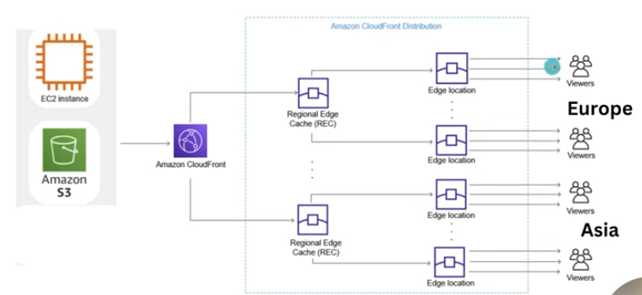

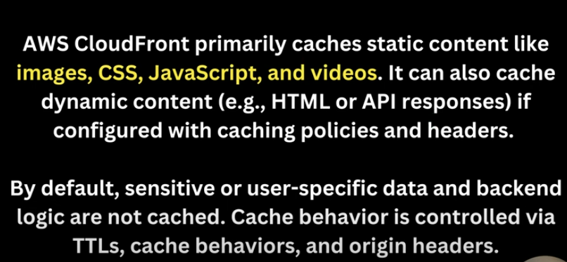

Amazon cloudfront->features(edge location)

Create s3 bucket->upload(add files)->aws ->cloudfront(create distribution)->distribution name(copy->paste on browser) form different region u can check speed of displaying image

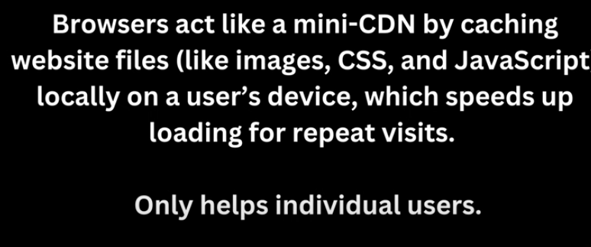

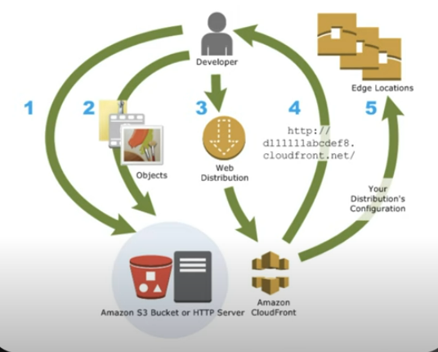

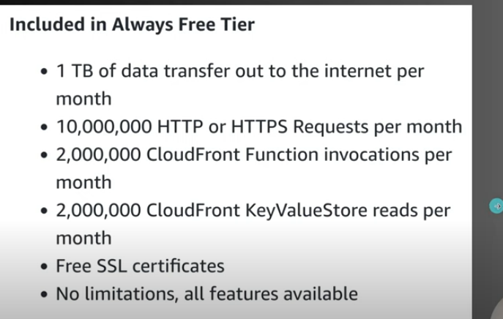

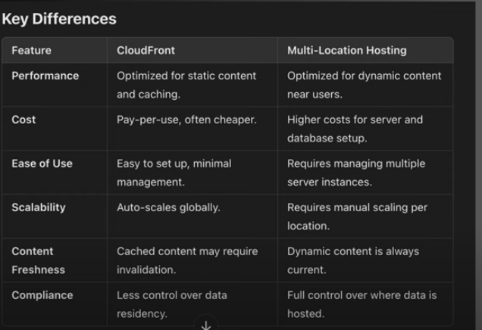

**ELASTIC CACHE**

It is a fully-managed, in-memory caching service provided by AWS.it improves application performance by storing frequently accessed data in-memory instead of fetching it repeatedly from slower disk- based databases.

## 🔹 Why use ElastiCache?

* ⚡ **High Performance** – Sub-millisecond latency for real-time apps.
* 📈 **Scalability** – Can scale in/out with demand.
* 💰 **Cost Reduction** – Reduces load on backend databases, saving compute/storage costs.
* 🔄 **Fully Managed** – AWS handles patching, backups, monitoring, and failure recovery.

## 🔹 Supported Engines

ElastiCache supports two popular open-source caching engines:

1. **Memcached**
   * Simple, multi-threaded, easy-to-use cache.
   * Best for simple key-value caching.
   * Use case: Storing session data, caching database queries.
2. **Redis**
   * More advanced, supports persistence, replication, pub/sub, and data structures (lists, sets, sorted sets).
   * Use case: Leaderboards, real-time analytics, messaging, session storage.

## 🔹 How it Works

1. Application requests data.
2. First check **ElastiCache** (cache hit/miss).
   * ✅ **Cache hit** → Data returned quickly.
   * ❌ **Cache miss** → Data fetched from DB → Stored in cache → Returned to app.
3. Future requests fetch directly from cache (reducing DB load)

## 🔹 Use Cases

* Web application acceleration (faster page loads).
* Gaming leaderboards.
* Session storage for web apps.
* Real-time recommendation engines.
* IoT and analytics.

## 🔹 Key Features

* **Cluster mode** – Scale horizontally by adding shards/nodes.
* **Replication** – Data replicated across multiple nodes for high availability.
* **Automatic failover** – If a node fails, AWS promotes a replica.
* **Security** – Integrated with VPC, IAM, encryption (in-transit & at-rest).
* **Monitoring** – CloudWatch metrics for performance.

✅ **In simple words**:  
ElastiCache = “Memory booster for your apps,” reducing latency and improving performance by avoiding repeated database hits.

**ECR**

E- elastic , C- container, R- registry

is a **fully managed container image registry** provided by AWS. It’s used to **store, manage, and deploy Docker container images** (or OCI-compliant images) securely and at scale.

## 🔹 Key Features

* **Private repositories** (default) and **Public repositories** (Amazon ECR Public).
* **Lifecycle policies** → Automatically delete old images to save cost.
* **Image scanning** → Detect security vulnerabilities.
* **Cross-region replication** → Copy images across AWS regions.
* **EventBridge integration** → Trigger events when images are pushed/pulled.

Aws->ecr->create repository->click on created repository push commands aws cli

IAM-> go to user->add permission-> then run commands of docker container build

**ECS(elastic container service)**

Is a cloud-based container management service that allows you to run and manage docker containers on a cluster of virtual server.

It automatically handles:

* Creation
* Management
* Updating

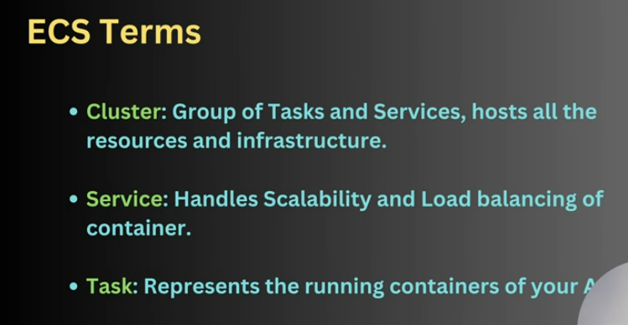

ECS-> create clusture->configuration open ip address it will show containers

**EKS**

**Amazon Elastic Kubernetes Service (EKS)** is a **fully managed Kubernetes service** in AWS.  
It allows you to **run Kubernetes clusters** without needing to install, operate, and maintain your own Kubernetes control plane.

## Why use EKS?

* 🚀 **Fully managed control plane** → AWS manages master nodes, etcd, upgrades, and patching.
* ⚡ **Scalability** → Auto-scales worker nodes (EC2 or Fargate).
* 🔒 **Secure** → Integrated with IAM, VPC, and security groups.
* 🔄 **Portable** → Kubernetes standard → same workloads can run on-prem, EKS, or other clouds.
* 🌍 **Hybrid/Multi-cloud** → Works with **EKS Anywhere** (on-prem) and **EKS Anywhere on Bare Metal**.

## 🔹 How EKS Works

1. **Create an EKS cluster** (AWS sets up the Kubernetes control plane).
2. **Add worker nodes**:
   * **Amazon EC2** instances (self-managed or managed node groups).
   * **AWS Fargate** (serverless – you don’t manage nodes).
3. **Deploy applications**:
   * Build Docker images → Push to **Amazon ECR** → Deploy using Kubernetes manifests (kubectl apply -f deployment.yaml).
4. **Manage workloads**:
   * Scale pods up/down automatically.
   * Use services/ingress to expose apps.
   * Monitor using CloudWatch, Prometheus, Grafana.

## 🔹 Key Features

* **Integration with AWS services**: ALB/NLB for load balancing, IAM roles for service accounts, CloudWatch logging.
* **Self-healing**: Kubernetes automatically restarts failed pods.
* **Auto-scaling**: Cluster autoscaler + Horizontal Pod Autoscaler (HPA).
* **Multi-AZ HA**: Control plane spread across multiple Availability Zones.
* **EKS Anywhere**: Run Kubernetes on your own data centers with the same tools

## Use Cases

* Microservices applications.
* CI/CD pipelines (run builds/tests inside Kubernetes).
* Big data & ML workloads (with GPU nodes).
* Hybrid workloads (part cloud, part on-prem).
* Gaming, IoT, real-time streaming.

## 🔹 EKS vs ECS (important!)

| **Feature** | **EKS (Kubernetes)** | **ECS (AWS native)** |
| --- | --- | --- |
| Orchestration | Kubernetes (open-source) | AWS proprietary |
| Portability | Multi-cloud & on-prem | AWS-only |
| Complexity | More complex (K8s concepts) | Simpler |
| Flexibility | High (customization, CRDs, Helm) | Low |
| When to use? | If you want Kubernetes standardization | If you want simple AWS-native orchestration |

**LAMBDA**

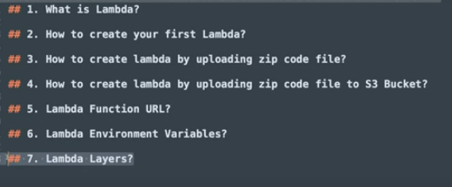

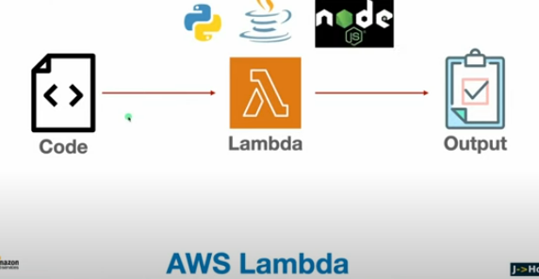

2.

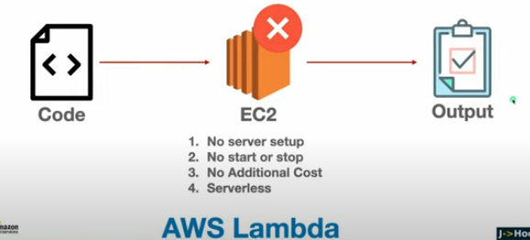

Aws-> lambda-> create function->upload code from

.zip file

Amazon s3 locartion🡪

Click on the bucket->upload file and select that bucket from s3 upload in lambda

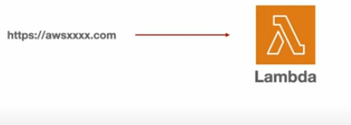

Click on created lambda function-> configuration url-> function url(auth type)

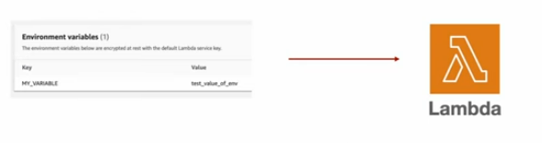

Create function -> configuration url-> environment variable

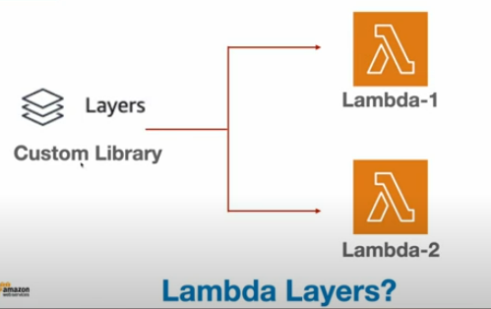

Aws lambda -> layers(create layer) for python

U have to create python folder inside that lib folder then create python version directory inside that site-packages folder and my_module folder create inside that __init__.py file and my_function.py file and zip this directory under lambda-layer

**COMPLETED AWS**